Woodstream Church

Habakkuk:
Evil vs. Good

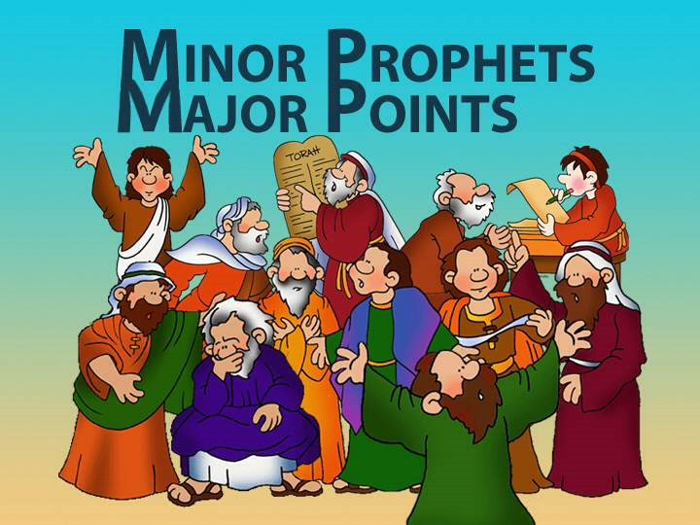

Women’s Institute
November 27, 2016
Habakkuk: Good Versus Evil
Introduction
Title:
- _________________________________________
- _________________________________________
- _________________________________________
- _________________________________________

Setting:
- __________________________________________
- ___________________________________________
- ___________________________________________
- ___________________________________________

Genre:
- __________________________________________
- __________________________________________

Author:
- ___________________________________________
- ___________________________________________

Date: _________________________________________
______________________________________________

Recipients:
- ___________________________________________

Major Themes:

Habakkuk frames the book into three distinct sections:
- ___________________________________________
- ___________________________________________
- ___________________________________________

Chapter 2 follows main themes found in the other prophets:
- ___________________________________________
- ___________________________________________
- ___________________________________________
- ___________________________________________
- ___________________________________________

Chapter 3 - _________________________

Outline
- ____________________________________(1:1-2:4)
A. Habakkuk’s first complaint
B. _________________________________
C. Habakkuk’s second complaint (1:12-17)
C. Habakkuk waits for God’s Response (2:1)
E. _________________________________ (2:2-5)

- ___________________________________ (2:6-20)

- First Woe: _______________________________
________________________________________

- Second Woe _____________________________
________________________________________

- Third Woe _______________________________
________________________________________

- Fourth Woe ______________________________
________________________________________

- Fifth Woe _______________________________
________________________________________

- ____________________________________(3:1-15

- Habakkuk’s Confidence in God Expressed (3:16-19)

